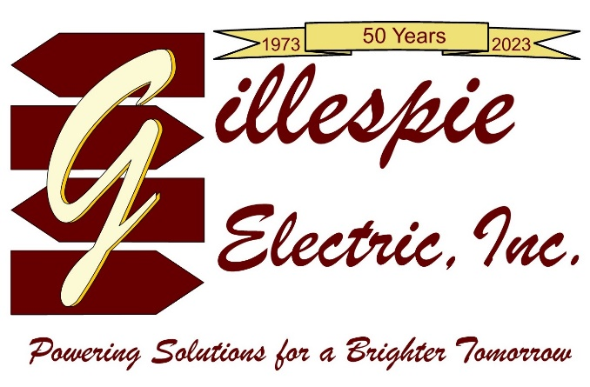

6/6/2023

To our valued customers,

Gillespie Electric, Inc is proud to announce that we are celebrating our 50th anniversary as an electrical contractor providing quality electrical service. Forty-seven years have been in the Upper Perkiomen Valley.

To celebrate this special event, we would like to welcome our customers to our office for two events. One on June 14th for our construction customers and one on August 16th for our service customers.

We would never have made it to such a milestone without our faithful client base and of course our fantastic employees. Our commitment to provide quality work both in construction and service has allowed us to establish unique relationships with our loyal customers.
We are proud of our accomplishments as a growing family-based business and believe that this is still only just the beginning.

